**Student’s name: Nguyen Trong Huy**

**ID: 20210451**

**Interface Specification**

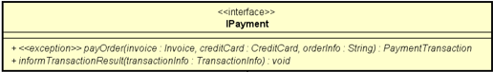

**1. Interface name:**

IPayment

**2. Interface description:**

The IPayment interface serves as a blueprint for payment-related functionality within the system. Its primary role is to establish a contract, defining the methods and properties that any payment subsystem within the system must implement. By adhering to this interface, different payment modules can seamlessly integrate into the system, promoting flexibility and scalability.

**3. Operation description:**

3.1. payOrder (invoice: Invoice, creditCard: CreditCard, orderInfo: String): PaymentTransaction

- Operation’s name: payOrder

- Description: this operation is responsible for processing the payment stage.

- Lists of parameters:

+ invoice: type: Invoice, the invoice that needs to be paid at VnPay gate.

+ creditCard: type: CreditCard, the credit card information that is responsible for payment.

+ orderInfo: type: String, the content of transactions, which defined by VnPay.

- Return type: PaymentTransaction

- Exception when there is not enough balance in the credit card to pay for the invoice.

3.2. informTransactionResult(transactionInfo : TransactionInfo): void

- Operation’s name: informTransactionResult

- List of parameters:

+ transactionInfo: type: TransactionInfo, the information of the transaction

- Return type: void